Design Document Draft

Team: No Clipping
Team Members: Reuben Aaron Beauchamp, Dustin Aguilar, Aaron Kim
Date: April 24, 2008
Concept Game: GAMMINAL

Table of Contents

Overview | 3
Schedule | 4
Personnel | 5
Technical Specifications | 6
Rules and Mechanics | 8
Artwork and Interfaces | 12
Gameplay and Balance | 18
Music and Sound | 22
Background Story | 24
Characters | 25
Levels | 26
Artificial Intelligence | 27

Overview
A large nuclear power plant has recently exploded next to a nearby zoo. Although no one seems to be hurt there’s a commotion at the nearby zoo.
What happens when you combine powerful, toxic gamma rays with normal every day animals?
Welcome to the mutated world of Gamminal. You take the role of Zephyr McGavin, an experienced zoologist who has a deep understanding of animal behavior and an unquenchable thirst for adventure. He’s sent to investigate the effects of the explosion at the zoo. However, soon after he arrives and sees the damage, he realizes that he will have to fight for his life to escape. Armed with limited supplies and weapons he must escape from the zoo and seek refuge elsewhere.
Gamminal is an exciting new first-person shooter set in modern times in the southern-most depths of California. It’s a game where you’re not only shooting animals, but mutated hybrid animals. You’ll be immersed in a comprehensive world filled with beautiful 3D graphics and stunning visual effects.
The gameplay will consist of using exploring environments and completing missions. In order to assist the player there will be various weapons provided to help defend against and to take out mutant animals. Each weapon will have different characteristics, having both advantages and disadvantages for different situations. Weapons will range from being close range (melee) to being usable at extremely far ranges. The player must decide on which weapon to use in different scenarios. Also, ammo throughout the game will be limited so the player must conserve their supplies unless they want to end up having to use their melee weapon all the time.
The mutated hybrid creatures in the game have a thirst for blood and will hunt you down if you cross their path. Each creature will have their own specific behaviors and characteristic so you will have to be on your toes so you don’t get caught off guard by an unexpected attack. So enemies or fast, some small, some fast, so slow. Gamminal will keep you guessing.
The game will be written using the C++ programming language and will take advantage of a free 3D graphics rendering called OGRE to produce and handle all graphical features.

Schedule
 | May 16 | June 4 | June 11
Reuben Aaron Beauchamp | 1. Create small temporary level (for use immediately for Person 2, 3)  2. Game Mechanics  (Firing, hitting, dying, health)  3. Create two large levels with obstacles and design elements | 1. Continue Game Mechanics  2. Sounds | 1. Finish Previous Work  2. Music  3. Networking  4. Multiple Instance of characters  5. Multiplayer
Dustin Aguilar | 1. Movements  2. Keys Setup  3. 3D Characters (get a couple out for immediate use for Person 1) | 1. Continue 3D Character work  2. Strategic Unit Placement | 1. Finish Previous Work  2. Networking  3. Multiple Instance of characters  4. Multiplayer
Aaron Kim | 1. Gun interface placements  2. Crosshair  3. Score Interfaces, Gun Menus, Setup Menus, Config Menus | 1. Artificial Intelligence | 1. Finish Previous Work  2. Networking  3. Multiple Instance of characters  4. Multiplayer
Note: One week prior to the first two deadlines, versions of the games will be assembled together by each of the three persons. The final week will be devoted to cleaning up and assembling the final version of the game and including music.

Personnel

Aaron Kim:
My personal role will include interfacing the gun with the player’s model, such that it will look like they are all one piece. Also, there is a need of a crosshair used for the player to facilitate his aim. I will also focus on building a general playing interface such as (score interfaces, Gun menu( selection), setup menus and Config Menus. I will also try to setup a multiplayer interface in which players could connect and play together. It is require for me to learn about a lot of graphics interfaces, OGRE SDK, and multiple players interface in c++.

Dustin Aguilar:
In order to complete the game that we’ve designed I will need to learn how to produce 3D artwork using a 3D modeling program, such as Maya. I will also have to have to try to become competent in basic animations. In addition to 3D modeling I will have to get more experience in C++ and learn how to use the OGRE engine so that I can import my models, have them behave appropriately in the game, and complete any other tasks I need to do to help complete the game.

Reuben Aaron Beauchamp:
My primary objective will be game mechanics. I will need to get the firing and hitting objects done accurately. Collision detection, health, and dying will also be vital to the development of the game. I will also be doing level design and incorporating sound and music. In the end, we all will work together to figure out how to do networking to attempt to make this an online multiplayer game as well. I will really learn the role of a game engine and how to manipulate it to give me desired effects. I will be learning C++ more extensively and potentially use my former OpenGL knowledge to further my understanding of computer graphics. I’m also very interested in setting up networking and creating multiple instances of characters. I believe I will learn quite a bit of useful information through this project that I can apply in future projects.

Technical Specifications
Team Name: No Clipping
Members: Reuben Aaron Beauchamp, Dustin Aguilar, Aaron Kim
Programming language: C++
Compilers/IDEs:
Microsoft Visual Studio will be our programming environment for this game.
Other Programs
3D graphics:
Blender/Maya for all 3D models
Both Blender and Maya are popular 3D modeling programs. Both are powerful tools used by large numbers of people with the main difference between them being that Blender is free whereas Maya is not. Most of our work will probably be done using Maya since it’s more powerful.
Textures and Terrains:
Terragen is a program we will be using for some of our levels and maps. It’s a program that can quickly generate nice looking procedural textures.
Adobe Photoshop:
A widely used image editing program that we will of course be using for our image editing.
Target Platforms:
Since the game will mostly be developed in Windows environment we expect the best results will come from playing on a Windows computer. However, since we expect that users will stay be able to run and play it on any machine that is capable using OpenGL or DirectX.
Engines Used:
We will be using a graphics rendering engine called OGRE to implement this game. It’s an engine that minimizes the effort it takes to create 3D scenes by taking care of the OpenGL and DirectX usage. OGRE is not specifically designed to be a game engine, it’s only meant to help with the graphical side of 3D applications.
Backup/Version Control:
We set up a website (currently where this design document is located) which we will be using to frequently upload our files to so that everyone can always have access to recent versions of all the different files we will be using during development.
Libraries:
We will primarily be using OpenGL, Ogre Gaming Engine, and IOStream Libraries/Packages.
Data Structures:
Our base data structures will consists of integers, doubles, floats, and strings. We may also create some structs for complex structuring. Arrays and LinkedLists will be mostly used data structures. Matrices will likely be used for positioning, as well.
Exact Algorithms:
There will not be any advanced artificial intelligence algorithms since animals aren’t very intelligent, especially mutated ones. We will implement a simple direct line following algorithm from the animal to the player for the early versions of the game. Later on we can implement greedy best-first search with strategic placing of points on the map (some A* would likely be involved) time permitting.

1. Rules and Mechanics

1.1 First Player Mode
1.1.1 Protagonist’s Movements
1.1.1.1 General Information
The main character, Zephyr McGavin, will move using the classic controls for a PC. The main character will be able to move quickly and decisively to evade the attacks of the mutated animals. He is bounded by the normal laws of physics and will move so accordingly.

1.1.1.2 Controls
W – move forward
A – move left
S – move backward
D – move right
Q – switch weapons
E – Special Action
R - Reload
Spacebar – Jump
CTRL – Duck
Left Click – Fire
1 – Select weapon 1
2 – Select weapon 2
3 – Select weapon 3
4 – Select weapon 4
Mouse Move – Adjust viewing angles
1.1.2 Damage and Hit Points
1.1.2.1 General Information
There will be three different types of guns. Each gun is specialized to attack certain types of animals. Normal bullets aren’t very effective on the majority of the creatures because of the thick hides they developed from mutation. Guns will have a maximum amount of cartridges the character can hold. The character will be able to hold 10 gamma launcher cartridges, 5 harpoons, and 6 RFML cartridges. He will start off with these amounts at the start of each level and must use ammo wisely to progress through the level. These amounts may vary from level to level, depending on the amount and size of creatures in each level.

1.1.2.2 Guns
Gamma Launcher
The first gun will be a small gamma ray emitting handgun. This gun is most effective on smaller animals. The gun will emit a green, squiggly line as it leaves the barrel to simulate gamma rays. The gamma rays cause copious amounts of damage to anything it hits render the body part useless. Unless the head has been stuck a few times though, these creatures will not go down easy. It contains 100 beams in each cartridge before it needs to be reloading. It can fire very quickly.

The Harp
This next gun is for use on larger animals. It fires a medium sized harpoon to penetrate the thick hide of the animals. After each harpoon is fired, it will disappear to conserve system resources. It will deal a large amount of damage to anything it hits, however the weapon is slow, so it will be difficult to hit your targets.

Rapidfire Mine Launcher (RFML)
This is the heaviest gun and most versatile. It can rapidly fire 5 mines in less than 7 seconds. It causes large amounts of damage to small animals but only some damage to larges, because of their thicker hides.

1.1.2.3 Melee Weapons
ZooBar
When the main character first arrives at the zoo, he discovers that normal weapons are useless against the thick hides and will not penetrate their skin. When he gets split off from the rest of his military team, he picks up a broken, sharpened bar from a zoo cage. He will use this as a melee weapon for the first mission.

1.1.2.4 Damage Gauges
Damages Character does to Animals
Gun | Speed (sec) | BodyShot  on Small | BodyShot  on Large | HeadShot  on Small | Head Shot  on Large | Cartridge Size
Gamma Launcher | 0.6 | 27% | 9% | 65% | 12% | 100
The Harp | 2.0 | 105% | 35% | 190% | 55% | 1
Rapidfire Mine Launcher | 1.3 | 80% | 20% | 110% | 30% | 5
ZooBar | 1.0 | 50% | 3% | 75% | 5% | none

Damages Animals do to Main Character

Creature | Bodyshot
HedgeRat | 5 damage
Hawke | 10 damage
Turtear | 15 damage
Tarkion | 20 damage
Whaguana | 25 damage

1.1.2.5 Defense Amounts for Creatures
1.1.2.5.1 General Information
Each creature will have a certain amount of defense. Bosses will also have added defense. To compute the damage of each shot this formula will be used:
Damage = Gunshot Damage * Animal Defense
i.e. Using the Gamma Launcher on a Hawke and hitting the body will produce this damage for each shot:
27 * 0.9 = 24 damage (always rounded down)

1.1.2.5.2 Normal Creature Defense
HedgeRat – 1 defense
Hawke - 0.9 defense
Turtear – 0.7 defense
Tarkion – 0.5 defense

1.1.2.5.4 Boss Creature Defense
Hawke - 0.7 defense
Turtear – 0.5 defense
Tarkion – 0.2 defense
Whaguana – 0.1 defense (primary boss)
1.1.2.5 Taking Damage
When a character is struck, their screen will flash red. The amount of health will show up on screen of a number from 1-100.
1.1.2.5 Health – First Aid Kits
To heal, a character merely will touch a first aid kit to apply it and give the character full health. These first aid kits will be placed strategically throughout the levels.

1.2 Multiplayer Mode
1.2.1 Character’s Movements
1.2.1.1 General Information
During multiplayer, each character that plays as a human will be given an infinite amount of ammunition. Creatures will only have the biting/clawing abilities. Once dead, each human/creature will respawn in 15 seconds from their death at their starting points. The starting points will be on opposite ends of the map and the first will last for as long as there are people playing.

1.2.1.2 Controls
The controls for multiplayer will remain the same as that of the first person part. However the animals, played by users, will need a new defined list of controls.
W – move forward
A – move left
S – move backward
D – move right
E – Special Action
Spacebar – Jump
CTRL – Duck
Left Click – Bite/Claw
Mouse Move – Adjust viewing angles

1.2.2 Damage and Hit Points
1.1.2.1 General Information
All the guns and melee weapons will remain the same from the first player mode. The percentages and formulas will also remain the same. The only added feature will be the player’s control over creatures. The creature’s moves will primarily consist of biting/clawing and strength of biting/clawing.

1.1.2.2 Biting/Clawing Damage Gauges
Creature | Speed Between Bites(sec) | Running Speed | BodyShot | HeadShot
HedgeRat | 1.0 | 100% | 20% | 45%
Hawke | 1.4 | 90% | 35% | 55%
Turtear | 2.4 | 50% | 40% | 75%
Tarkion | 2.0 | 60% | 50% | 65%

1.1.2.5 Taking Damage
When a character is struck or shot, their screen will flash red. The amount of health will show up on screen of a number from 1-100.
There is no friendly-fire in multiplayer. Later implementations can include it but this version will not. There are no first aid kits in multiplayer.

2. Artwork and Interfaces

Conceptual Art: In-Game Interface
Interface Gamma Gun
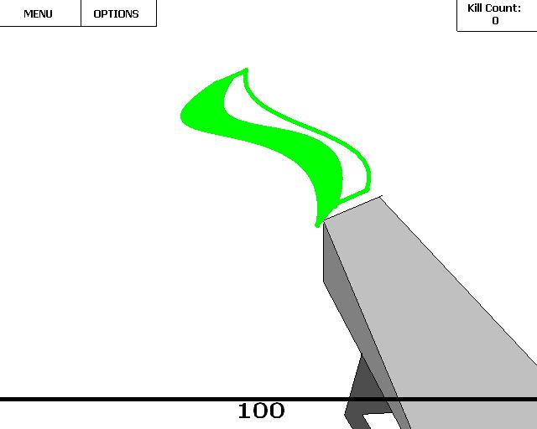
Early Designs of the interface and the gamma gun. It will emit a ray like beam that will fly to its target.
Interface Mine Launcher
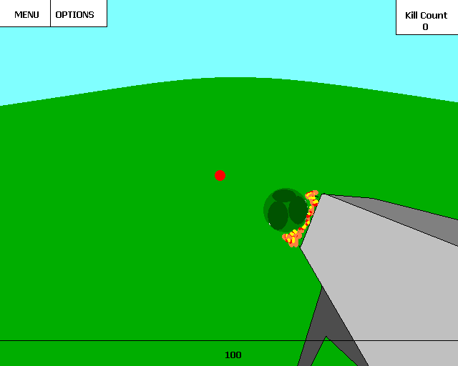
Another early design of the interface. Shows mine launcher, mine, and crosshair designs.

Conceptual Art: Animals
Original Animals
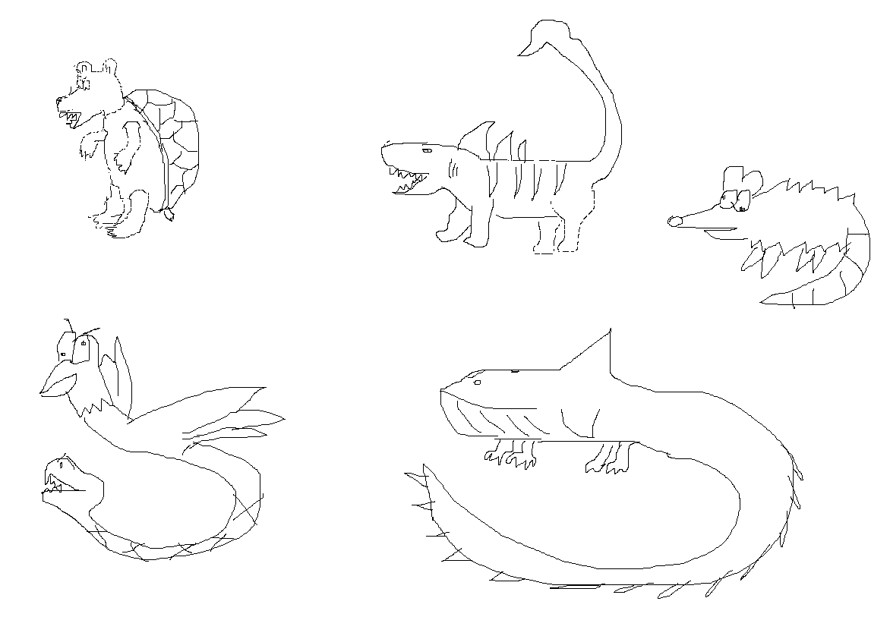
This image was the first drawn concepts of the unpolished animals. These are going to be used as references to model the polished versions.
Whaguana
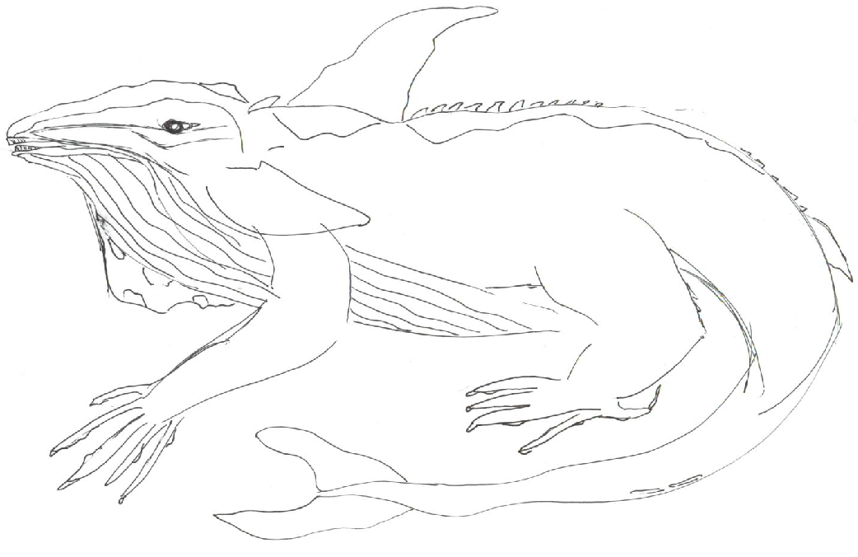
A more refined drawing of the Whaguana. This creature will be very large in proportion and will likely go through a few more changes before it goes into the game.

Conceptual Art: Environment
Zoo Scene
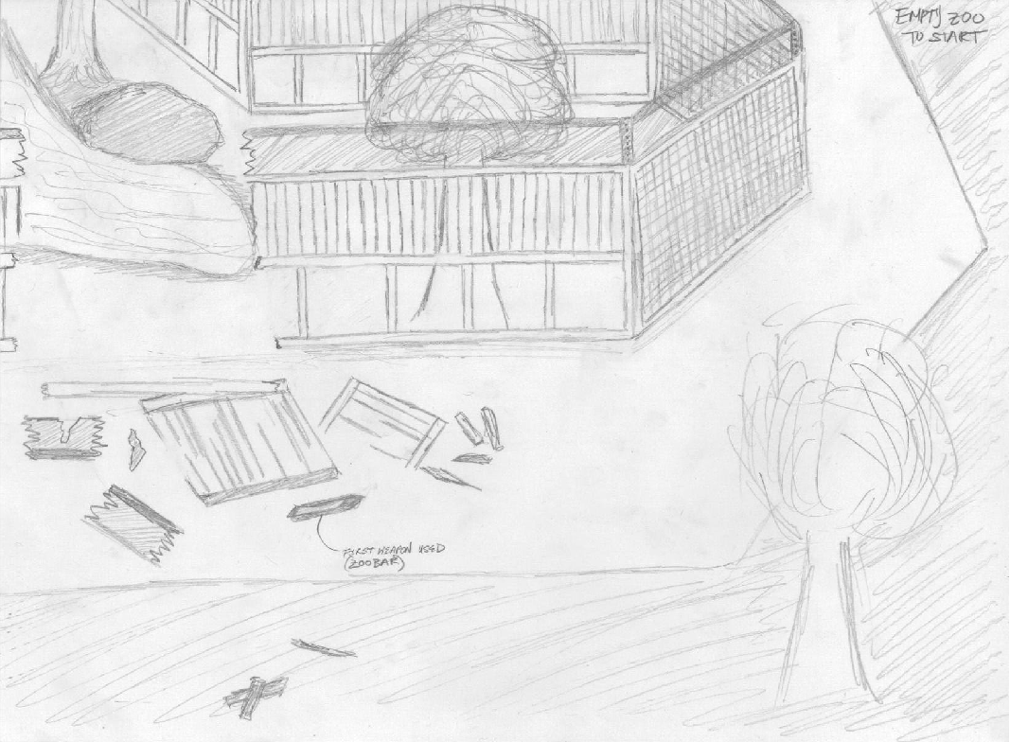
This drawing shows the classic zoo environment with a broken fence. Animals will be escaping through wholes in fences like these. Also the zoo bar is shown at the bottom and the main character will pick it up once he walks over it.
Starting Position
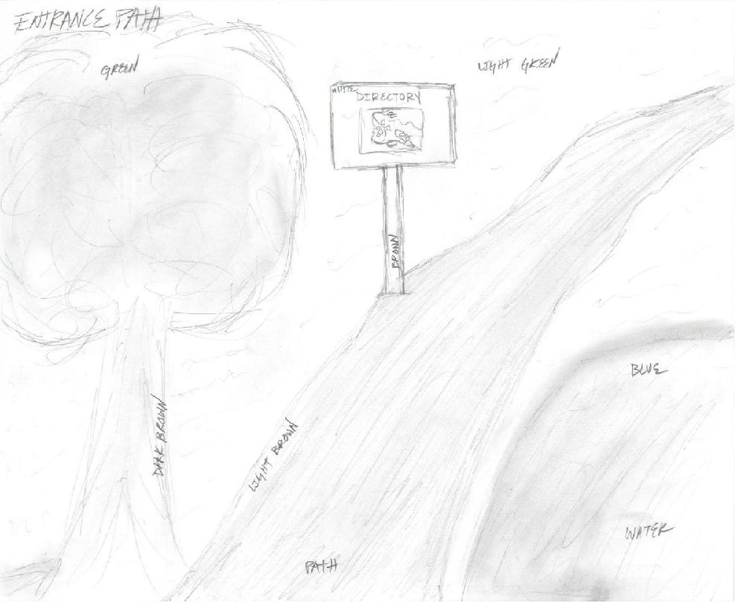
The character will be starting at the beginning of the zoo. He will see something that resembles this scene in the beginning.

Digital Art: Guns
Gamma Gun
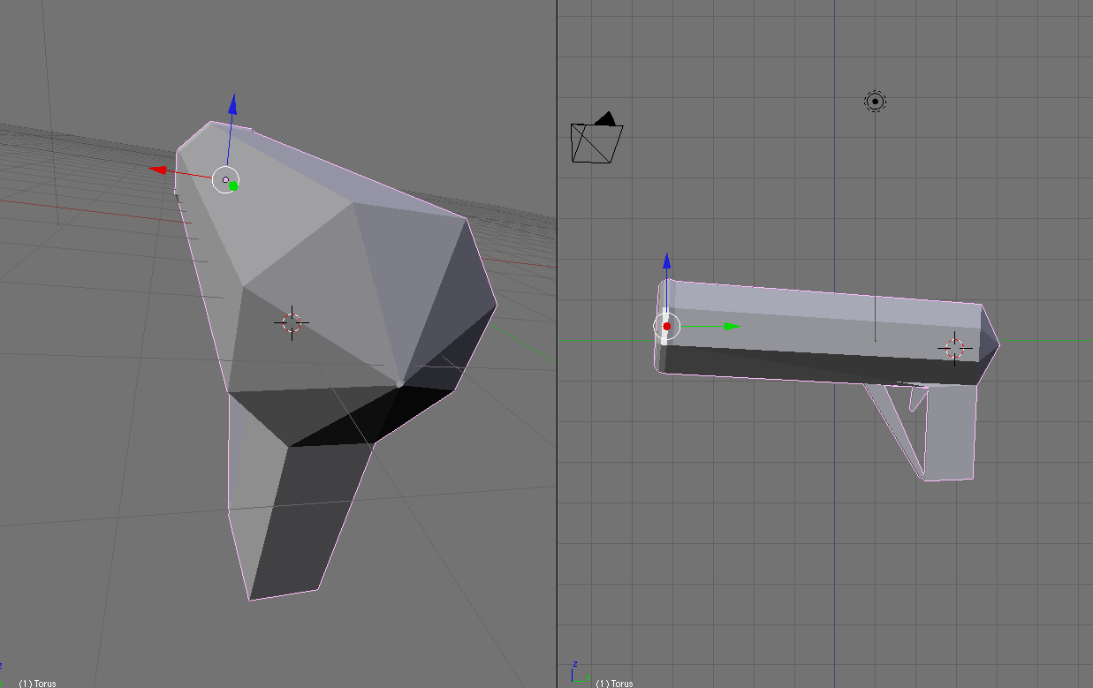
The first gun made by Dustin in a 3D designing program called Blender. Its primitive design matches the look we are going for in the Gamma gun.
Harpoon Gun
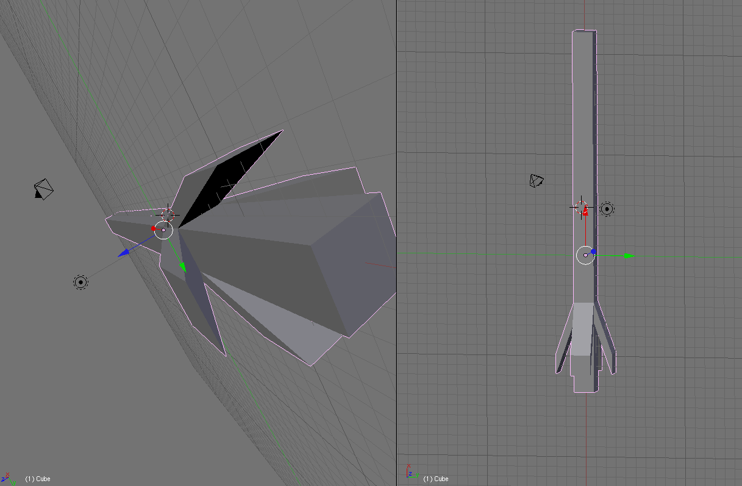
This gun is designed to be very long so that a harpoon would be able to fit inside of it. It has a slot that resembles an opening for the harpoon to go into in the back.
Mine
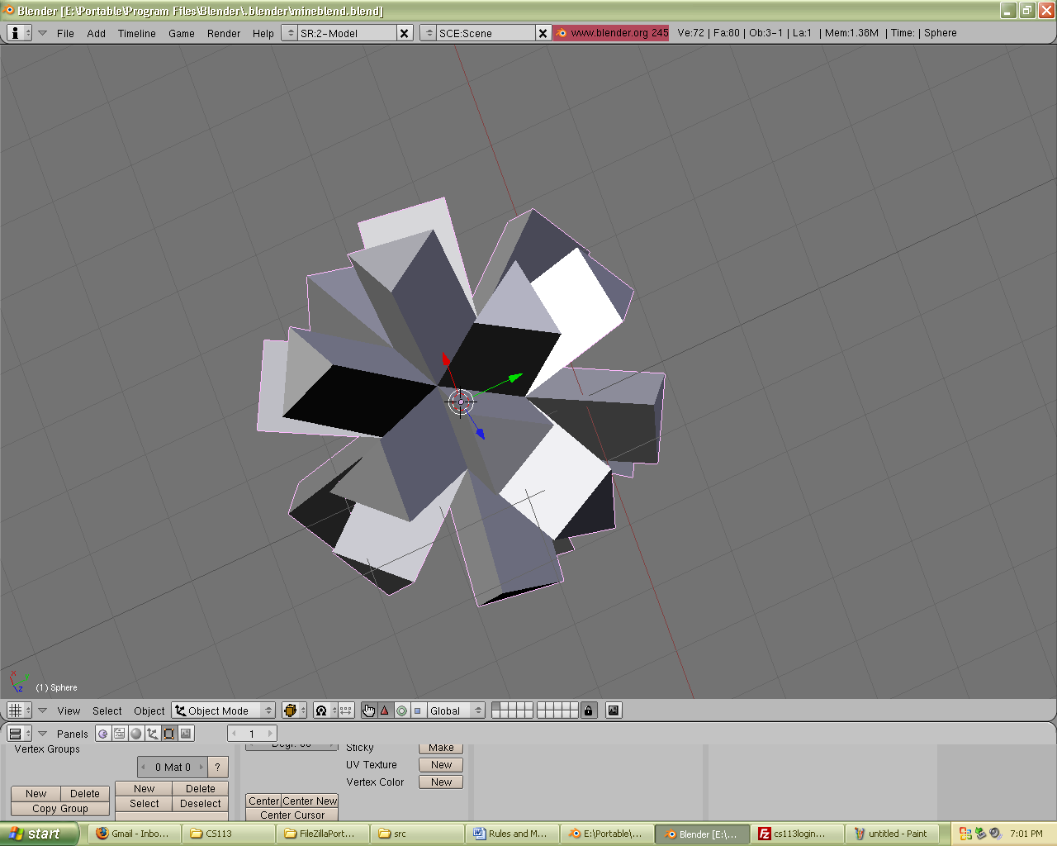
This is a mine that will be launched by the mine launcher. It resembles the type of high explosive mines found in body of waters to blow up boats.
Mine Launcher
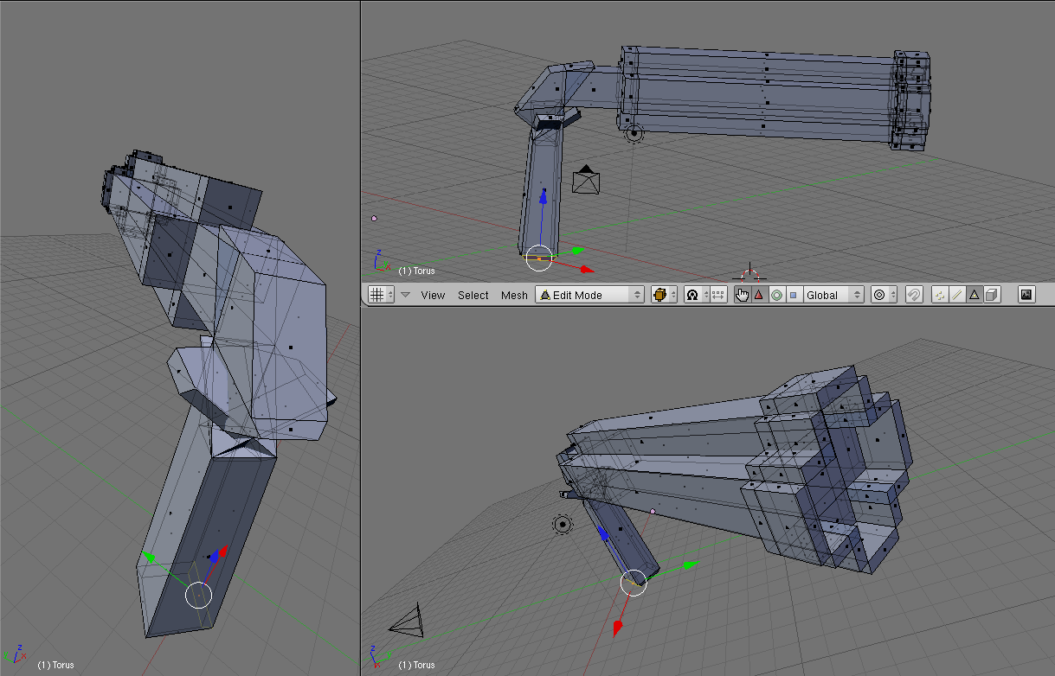
This is the mine launcher. It has a large opening at the end of the barrel so that the mine should fly right out. It was the third gun designed and appears more advanced than some of the other primitive guns.
Digital Art: Environment
Flat Landscape, textured ground, and bright green splash in the middle
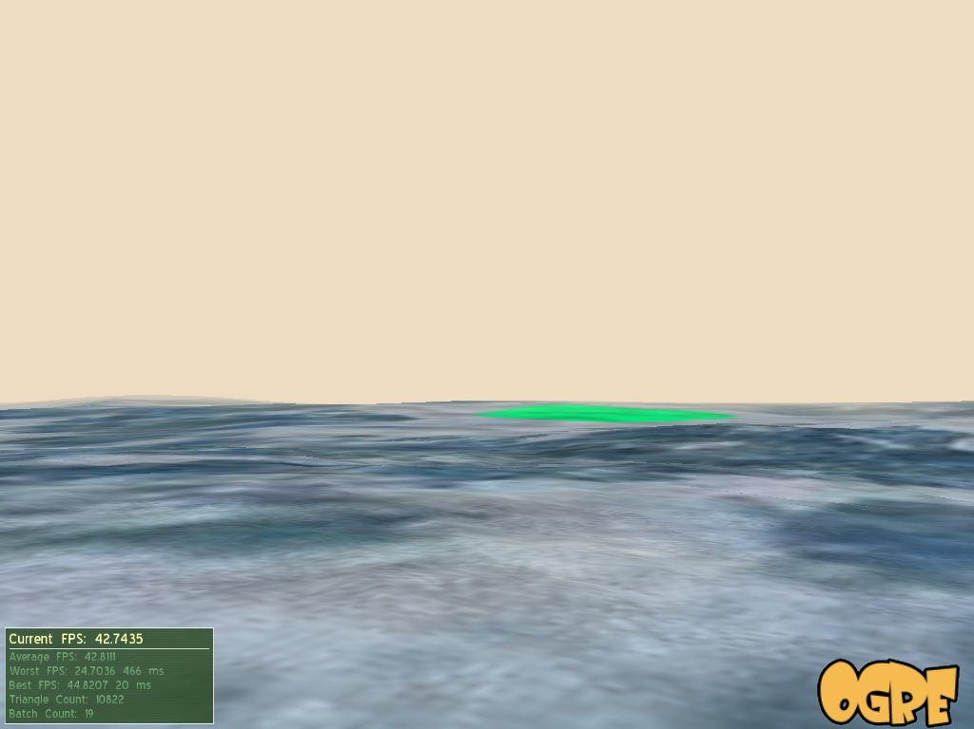
This is an actual scene taken as a snapshot from the ogre engine. Aaron designed the landscape, texture, and color of the environment using images as references to model off of.

Gameplay and Balance

3.1 Movement

3.1.1 The player will be able to move forward and backwards, strafe, duck, jump, and select multiple guns. He will be able to select from different guns throughout the game. Player will have to crawl, jump and run through many different obstacles found in each of the level scenarios.
3.2 Environments Visuals
3.2.1 The player will have notion of the surroundings with a panoramic view of 120 degrees on the x axis and 60 degrees in the y axis.
3.2.2 Different creatures might be interacting indirectly with the player or be part of the environment.
3.2.3 Player will have the ability to view any angle position through the use of the mouse or the keyboard.
3.2.4 Lighting could differ depending on the course of the game (Night or Day time)
3.2.5 Fog of war could be used to decrease the amount of graphical computation of elements outside of the range of the player.
3.3 Environment Sound
3.3.1 The player will perceive the environment sound in a stereo signal mode. Different levels will have specific sound effects according to the scenario that the player is in.
3.3.2 The environment also includes different animals' sounds that might react to the presence or actions of the player.
3.3.3 Personal movements will include footsteps, switching of guns, grunting and death-like simulation for a realistic behavior.
3.3.4 The environment could be run with background music, or a mix of environmental sounds.

3.4 Weapons
3.4.1 All weapons will be available to the player at the beginning of each level with limited ammo.
3.4.2 Weapons would have a red laser dot as an aiming feature.
3.4.3 Recoil and trajectory of the weapons might differ with the variety of weapons.
3.4.4 Stronger weapons having a greater impact on the players posture, whereas weaker weapons being barely noticeable to the players reaction.
3.4.5 Ammunition would be used for some weapons. The player will start out with all ammo he or she will have for the entire level.
3.4.6 Picking up ammunition or guns will consist on just walking at a near distance from the gun or weapon.
3.4.7 Weapons may not be lost once they are acquired in the game; however, ammunition could limit its use once it reaches zero;
3.4.8 Health packs could be picked up and used throughout the game. It will eventually heal (increase players' health points) up to a certain level according to the type of health pack being picked.
3.5 Missions or Assignments
3.5.1 Throughout the game the player will have to accomplish missions to go to the next level.
3.5.2 Missions could consist on reaching a certain point, or eliminating a certain creature.
3.5.3 Other extra features could include staying alive for a certain amount of time.
3.6 Controls
3.6.1 Controls such as the mouse and keyboard might be able to be customized by the user.
3.6.2 However, there will be a default preset of its functions.
3.6.3 Left mouse key will be used to shoot. Whereas right click can be used to zoom in with certain weapons.
3.6.4 Jumping could be done with the space key to go over some of the obstacles throughout the environment.
3.7 Physics
3.7.1 Physics on the game will be very similar to the real world.
3.7.2 Ammunition will be carrying a lot of force, being able to produce more damage if the enemy being shoot at is at a closer range.
3.7.3 Shooting guns can also produce certain recoil as the effect of pushing ammunition out and counterbalancing its power by transferring this force to the player by pushing or disturbing the player's balance or posture.
3.7.4 Gravity will also play an important factor on different aspects on the game.
3.7.5 Gravity will modify the player's ability to jump over obstacles having a certain height that he can reach.
3.7.6 Gravity under water might have different characteristics than on an open space. Normal jumps might give the player higher heights.
3.7.7 Jumping down from a higher ground might injure the player proportionally to the height he jumped from. Thus, simulating real life injures due to the force exerted against the floor from the user's mass and earth gravity.
3.7.8 Gravity also affects different guns. The harp carrying a lower level of ammunition speed will slowly decrease its altitude as certain levels of length are reached.
3.7.9 Grenade launchers ammunition will also have an inversed parabola trajectory from the position that the player shoots it out.
3.8 Difficulty
3.8.1 Difficulty of the game will be based on effectively eliminating enemy creatures without getting killed (receiving too much damage done on the player).
3.8.2 Different creatures will have a different percentage of damage; thus, presenting a challenge to the player throughout the game.
3.8.3 Many creatures could be presented at the same time to attack the user. This will be presented as a different type of challenge since many creatures ( of lesser power) could simultaneously do damage to the player.
3.8.4 Trying to find the route to the checkpoint location could be also challenging as the amount of enemies show up throughout the game and the visibility of the area decreases as the night approaches.
3.8.5 Two modes of difficulty could be used. Normal or Difficult
3.8.6 Normal mode will start as the first option. Once the player finishes the game, a hard mode would be included as an option
3.8.7 Hard mode will differ from the normal option by increasing the amount of enemies and increasing the amount of damage that each enemy does.
3.8.8 In case that the player reaches a health point percentage of less than 0, he will lose his life. Thus, letting the player start the game again from one of the checkpoints with a full percentage of life.
3.8.9 Different checkpoints will be distributed throughout the game, so that the user does not have to completely restart the game. They will be usually located throughout a midpoint of a level.
3.9 Multiplayer gameplay
3.9.1 Different modes could be implemented for multiplayer
3.9.2 Cooperative mode will consist on finishing playing the game cooperatively with a multiplayer partner. Thus, the level of difficulty will have to be highly raised to make it challenging enough.
3.9.3 Deathmatch mode will consist on a multiplayer game in which users connected to the game will have to fight against each other.
3.9.4 Only the Zoobar (melee weapon) will be unlimited throughout the game.
3.9.5 Different maps will have different types of guns that will respawn after a certain amount of time in specific locations.
3.9.6 A score based system will be implemented to show how many kills the user has done to certain players and how many times the player died.
3.9.7 Killing another player will consist on shooting until the other player is dead
3.10 Gameplay Balance
3.10.1 Gameplay balance is leveled so that the user will not always have enough ammunition to kill the creatures.
3.10.2 Difficulty increases throughout the game, but the skills of the players will also increase. Thus, there is a specific level of difficulty implemented to keep the playing level challenging and at the same time not too difficult.
3.10.3 Balancing of the enemies will be done accordingly while testing the game. Changes for the gameplay difficulty could be done by decreasing or decreasing the level of damage of the player’s ammunition, or increasing or decreasing the health of the enemy units.
3.11 Gameplay overall
3.11.1 Gameplay will basically be focused on a first person action shooter with an immersive environment that interacts with the user through sound, exotic scenery, and animated characters.
3.11.2 Game is designed to be rated for teenagers, since blood, action scenes will be involved in the game.
4. Music and Sound
4.1 Sound effects Sources

4.1.1 The sound effects will be made using in house sound recording. We will use a microphone and a program to extract the sound (i.e. RecordPad Sound Recorder 2.11). Then we will use our own sound effects from everyday sounds. For example, for shooting weapons, we may hit to glass bottles together. We will need sounds for each gun, biting, clawing, running, and jumping.

4.1.2 Some extra sound examples might be extracted from different a variety of game packs such as: Quake3, Quake2 game packs.
4.2. Sound attributes to each object

4.2.1 Player’s sounds will include running, walking, jumping, grunting (bullet hitting player), player falling of a cliff, player hitting the ground.

4.2.2 Weapon’s sound

4.2.2.1 Gamma launcher will consist of a rapid consistent sound that mimics the piercing of the slugs through air having a high and low frequency pitch.

4.2.2.2 The harp will consist of a solid mid low frequency short sound. It won’t have a rapid firing qualities, so one instance of it might be enough.

4.2.2.3 RapidFire Mine Launcher: Will consist of throwing a burst of Mines. This sound will have a strong Bass sound with some reverberation to mimic how the mine gets farther away from the player as is being shot out.

4.2.3 Ammunition sound
      - Bullets will have a sharp short mid sound as they hit a wall, rock or any hard surface.
      - Harpoon will have a louder noise as its force due to its size will create a greater impact sound as it reaches its target.
      - Gamma ray’s slugs will have a very subtle noise creating the feeling of an object breaking through air.
      - Mines: Will create a big explosion sound as they hit the target.

4.2.4 Melee weapons sounds
4.2.4.1 Zoobar: is the only melee weapon being used in the game. It will basically make a metallic sound as its hits the targets.

4.2.5 Item sounds
4.2.5.1 Picking up health will emit a sound to let the player know that he just has been healed.
4.2.6 Creatures sound

4.2.6.1 Hawke: will have a mix sound of a hawk with the hissing of a snake. A constant flying sound could be implemented to simulate that the Hawke is flying. Attacking a pray could also signal an approached attack sound done by the hawk.

4.2.6.2 Turtear: Will basically have giants step sounds due to its size. It also includes, a loud roar when he is about to attack a pray or the player.

4.2.6.3 Tarkion: Will have a weird modification of a tiger’s roar. He will also have muddy footsteps since by being a hybrid he will constantly be wet.

4.2.6.4 Whaguana: Whale like sound could be used for this animal as he prepares an attack. We can also hear the whaguana at a long distance due to its constant breathing.

4.3 Environment Sound

4.3.1 Level sounds. Since the game consist of 4 different missions, each mission will have a set of different environmental sounds.
      - Mission 1: Will have mild sounds of the zoo animals, such as elephants, birds, lions.
      - Mission 2 (Jungle scenery): Will have more exotic type of noises as the player gets into the vegetation. This includes, bug noises, reptiles hissing noises, cougars, water dripping and birds.
      - Mission 3: (Civilization): this level will consist of city like sounds as he approaches them. We could include sound of car crashes or explosions or fires taking in place.
      - Mission 4: (escape from humanity): will feature sound of the ocean and breeze noises as the player gets closer to the beach.
4.3.2 Environment effects: Depending of the player’s location, different sound effects (gun walking, movements, shooting) will have a slightly different feeling depending on which mission the player is. For example: Ocean like environments will have a very solid noise without any effects since no walls are in to reflect sound back. Also, the fade out of the sound will be faster. Sound effects at the city will have a higher delay effect to give the feeling that the city has been abandoned and only echoes of sound can only be heard through the destroyed city.
4.4 Music
The music will be an original score that one of our members will make. One of our members will make a few songs using a guitar, and will be editing using a song making programs such as GarageBand. We will need music for the intro, saving, and each of the four levels.

5. Background Story
5.1 Background Story
For years humans have lived off nuclear power. Mass protests arose during its early years because people never thought it was safe but scientists have many times proved that nuclear energy is the cheapest and most efficient way to go in terms of power. 50 years after its entrance on the scene, the public has grown used to the use of nuclear power. It pervades every single home and business and is a support beam for the US economy.
Flash forward ten years.
It’s a warm, calm, sunny day in San Diego, California. There’s a special event going on at the local zoo and thousands of people have come to witness the unveiling of the endangered Golden Lion Tamarin. However, unbeknownst to anyone, there’s a faulty nuclear reactor nearby about to explode. No scientist ever took into account the effect of extreme electrical fluxes in the earth’s core. Every physicist knows that a high-speed, mass collision of photons with a nuclear reactor will only lead to disaster. Nobody was thinking about it on this beautiful day. Minutes before the unveiling at the zoo the nuclear reactor can remain stable for any longer and explodes in a delicious display of flying plasma and waste, launching nuclear rays toxic goo all throughout the vicinity of southern California. At first it seems that the goo has no effect on the health of anyone but then, suddenly, chaos begins at the local zoo. It seems that the nuclear material targets only a particular gene only found in non-humans. This causes all the animals in the zoo to fuse together and mutate wildly in freakish beings bent on destroying all human life on earth.
The only man who can save the world is world-renowned zoologist, Zephyr McGavin. With his extensive experience with animals and solid combat training he will be sent to put a stop to these animals. He is sent to investigate the situation and to try to come up with a solution but after looking at the animals and the damage they have done and can do, he makes a startling realization: the large quantity of gamma ray emitted from the explosion has caused this. It was what he had been studying for the past few months in his lab at UCSD, except that this was on a much grander scale. He comes to the conclusion that there is no way for mankind to stop these rabid beasts. He makes an attempt to escape from the zoo and find safety in a nearby city, only to find that civilization is being dominated by these unstoppable beasts. The game ends with him trying to escape civilization on a giant ship to stay out on the ocean out of harm’s way. The twist comes when he sees that ocean dwelling animals have fused with land animals, so there really is no escape. The final scene is of him sailing into the ocean with doubts about how much long he and the rest of humanity will have to live.

6. Characters
6.1 Human Characters
6.1.1 Zephyr McGavin
The main protagonist. He’s a zoologist who got his PhD at Harvard. He’s traveled the world studying all the different types of animals and also happens to have extensive combat training from his days in the military. Fresh from his one-year expedition at Borneo, he had been called in to do some research at UCSD on the
effect of gamma rays on mice before he was sent to investigate the incident at the
zoo.
6.1.2 Victim
These NPCs will be the helpless citizens who can’t defend themselves from the mutant animals.
6.2 Animals/Enemies
6.2.1 HegdeRat
A hedgehog-rat hybrid animal. It will have the basic body shape of a rat but it will be about as big as a hedgehog. These creatures will be quick and hard to hit but getting one good strike in will take it down.
6.2.2 Hawke
A combination of a hawk and a snake. It with be a flying animal with the wings and talons of a hawk but it will have a snake’s tail that will hang down. This creature will want to hang back until it sees an opportunity to attack and then swoop down to do some quick damage. It has fairly good range since it can also do damage with its snake tail.
6.2.3 Turtear
A mix between a giant turtle and a bear. It will have the body of a bear with the shell of a turtle on its back. This combination of characteristics will cause it to be very powerful along with having high defenses to defend against attacks. A disadvantage it has is that is has to be at a close range in order for its attacks to connect.
6.2.4 Tarkion
A special animal hybrid that fused together from three different animals. It’s a combination between a tiger, shark, and a scorpion. It is extremely ferocious and has the high attack power of all three animals it’s made up of. It has the speed of a tiger, the hard exoskeleton of a scorpion, and the killer instinct of a shark.
6.2.5 Whaguana
A hybrid between a blue whale and an iguana. It with have the body and size of a whale except that its tail will extend out a long ways like an iguana’s would. Also, it would have 4 iguana-like legs and feet so it could travel on land. Although it’s extremely slow, it will be very powerful and difficult to defeat. Since it has the long iguana tail it can attack the player from long ranges and also shoot a high- powered jet of water at the player.

7. Levels
7.1 Mission One: Attack at the Zoo
This mission starts at the zoo entrance. The player will arrive with a group of military personnel to assist you but you quickly get split up from your group. The goal of this mission is to investigate what’s going on and stay alive. The level will be based around the zoo so there will be broken cages, dying people, some wildlife settings and also man-made buildings. The mission will end when the player reaches a predetermined part of the zoo that will trigger a boss battle. The boss battle will be against a Hawke. After the battle is over the mission will be complete.
7.2 Mission Two: Escape from the Zoo
After the boss battle from the previous mission you find out that the main entrance of the zoo is blocked and inaccessible so you must continue further into the zoo to find an alternate exit. This requires that the player travel into areas of the zoo that have higher vegetation (aka jungle scenery).
At the end of this mission the player fights another boss battle against a Tarkion. Soon after the battle the player will find a ladder leading out of the jungle exhibit and over a wall that leads outside of the zoo.
7.3 Mission Three: Into Civilization
Now that the player has found his way out of the zoo and seemingly out of harm’s reach (at least temporarily) his next goal will be to go into the nearby city and try to find some sort of assistance. However, as he draws closer he begins to encounter mutant animals along the way and must fend for his life once again. The levels starts out in a mountainous terrain but as the level progresses the land gets flatter and flatter, signifying that the city is drawing near. At the end of this level the player will fight another boss: the Turtear. After the boss battle he will reach the outskirts of the city.
7.4 Mission Four: Escape from Humanity Upon arriving at the city the player will see that the city is overrun by these mutated animals and the only option left is to head from the harbor and escape into the ocean through the use of the giant cruise ship parked in the water. The city will be filled with every animal encountered so far and navigation will be tricky since there will be no map and the player won’t quite be sure where the harbor is. Once the player reaches the docked ship he will have get onboard only to be faced with a final boss battle against a giant Whaguana. After the battle the player will have to navigate to the control room.

Artificial Intelligence

8.1 Artificial Intelligence
8.1.1 Aggressive Mode
When a character approaches any of the enemies, say within 20 yards (differs between animals) in game distance, the aggressive mode will be turned on and the animal will attempt to attack the character. If the animal runs into the character, this will be defined as being hit (bitten or clawed). They will follow a straight line path towards the character and stop at walls. It will follow the character for as long as the character is near it. The only way to break it out of an attack once it begins it to damage it or move out of range. The AI will be purposefully be unintelligent since they are merely animals.
8.1.2 Passive Mode
If the animal has not been provoked then it will be set in a passive mode where it aimlessly wanders around. Once a threat has been detected nearby then it will then go into aggressive mode. Every animal starts off in passive mode when the level is loaded.
8.1.2 Specialized Character AI
Each animal will have the general AI mentioned above. However, each animal will be given unique characteristics and behaviors.
8.1.2.1 Victim
Victims will be manually placed by us, the developers. Their default behavior will be to stay in place while in a crouching position. They will keep track of what's happening inside a predefined bounding sphere. If they detect that an animal has come too close they will be programmed to run away in a direction opposite the direction of the approaching animal. They will mainly be used as a diversion the player can use to lure animals away from him since the animals will be programmed to chase the closest person to them.
8.1.2.2 HedgeRat
HedgeRats will be the most abundant enemy in the game. Because of its large population, these animals will be continuously being respawned in levels. We will make sure they spawn outside of the view of the camera so the player doesn’t just see one appear out of nowhere. Its field of vision will be large since it can hear well with its big ears.
Passive: These creatures will aimlessly wander from point to point at a very fast rate. They will calculate their next point immediately after arriving at their current point and then move again right away and at a quick pace.
Aggressive: Upon seeing a human to attack these animals will charge straight for them and make a jump at them a from just a few feet
8.1.2.3 Hawke
Hawkes will be the second most abundant animal in the game. Since it is one of the weaker animals along with the HedgeRat, it will be set to respawn periodically, although at a lower rate since they are more powerful that HedgeRats. Since it's the only flying creature we have its behavior will deviant slightly more from the basic algorithm. It will always remain in the air unless it is killed, then it will fall to the ground and disappear. There will be a predefined constant that defines the maximum height it can fly along with how low it will fly.
Passive: There will be a large invisible bounding sphere around the Hawke. Each time it moves it will pick a point within this sphere to move to. If it falls within its global movement boundary then it angle itself in the direction it's about to travel and them move to that point at a medium pace.
Aggressive: The Hawke will have a very large field of vision (this will probably be another bounding sphere. If a human travels within this sphere then the Hawke will go into attack mode. Since it will most likely be much higher than the human it will be programmed to take a straight-line path down to where the human is to attack it. The Hawke will have two attacks to choose from: it can either ram you or use its long snake-like tail to whip you.
8.1.2.4 Turtear
The Turtear will be the first animal encountered that is too powerful to be set to respawn. They will be manually placed in the levels that they appear in so that once one is defeated it will not come back.
Passive: In passive mode the Turtear will be down on all fours similar to how a turtle would walk. It is extremely slow in this mode. It will be programmed to rotate about, looking in several directions, then finally it will choose a place it wants to move to and move their slowly. Sometimes it will not move at all and just stay frozen in one place. Its field of vision will be medium-sized.
Aggressive: As soon as it senses a human nearby the creature's behavior will change radically: it will get up on its hind legs and charge directly at the player at a much faster pace than it would normally travel in passive mode. The animal's attacks are to just ram into the payer, swipe at him with its claws, or just bite ferociously. Basically, if it gets close to you, you are taking heavy damage.
8.1.2.5 Tarkion
The Tarkion is perhaps the most fearsome beast in the entire game. Its senses are top-notch and will detect a human from extremely long distances. It will also be very stealthy and not make much noise, along with trying to stay out of the player's vision. Its only disadvantage is that it can only attack from close range. However, when it does get an attack in it will leave the player severely damaged. Tarkions, like Turtears, will be manually placed on the map in small numbers and will not respawn.
Passive: The movement of the Tarkion will be erratic when in passive mode. Sometimes it will stay still in one place, other times it will scurrying from one point to another similar to a HedgeRat, while at other times it will pick a point very far away and travel to it at a brisk pace.
Aggressive: When you are detected by the Tarkion it will try to keep its attacks as stealthy as possible. This means it will not do the traditional straight-line attack directly at the player. It will attempt to run out of the player's view then take a straight-line path it can no longer be seen. Once it gets close enough it will cause devastating damage to the player, much like the Turtear.
8.1.2.6 Whaguana
Since Whaguanas are one of the more powerful creatures the player will face they will be carefully placed and their numbers will be very low.
Passive: Will randomly pick a point a certain distance away from it (this will be like the radius of its movement) and move very slowly to that point. In between movements it will pick one of several animations to display, such as swinging its tail around or shooting water out of its blowhole.
Aggressive: Will slowly move towards the player until in range for an attack. Since this creature has some fairly long ranged attacks it doesn’t have to get too close and can start attacking unexpectedly from a distance. Its long range attack involves shooting a ball of water at the player from its blowhole. It will be aimed at the position that the player was at during the time of firing and will travel in an arc due to gravity. The creature's closer range attack involves whipping the player with its tail. This will involve the creature getting close enough for its tail to be able to reach the player. When in range, the Whaguana will do a rapid spin (which just involves it rotating 360 degrees at a fast pace), hopefully hitting the player with the length of its tail.

